**Assignment 4 Analysis**

**Data Overview**

Schools_complete.csv and students_complete.csv files were analysed to evaluate school performances in Reading and Maths in a single Local Government Area and comparing the results against different variables.

The results obtained provide insight into:

* the level of funding that may be required to achieve optimal and desired high school student education levels
* performance of each school that can enable parents to make better decisions for school of choice for their children
* Schools to identify how well they are tracking in their performance goals and how they are trending against other schools.

The overall results indicate that the 15 schools in the LGA performed very close to each other in relation to average Maths and Reading scores although there was a bigger separation when looking at overall passing scores (passing both Maths and Reading) where Griffin High School was the top performer at 81.33%, and Ford High School the worst at 67.47%.

Figure : LGA Summary

(Continued next page)

Figure : Per school summary

Figure : Top performing schools

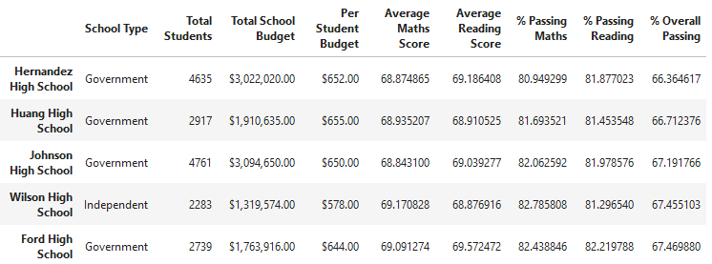

Figure : Bottom performing schools

The analysis of yearly performance in Maths and Reading provides a good insight in skills levels at different ages, however the annual fluctuations observed at some schools should be investigated further.

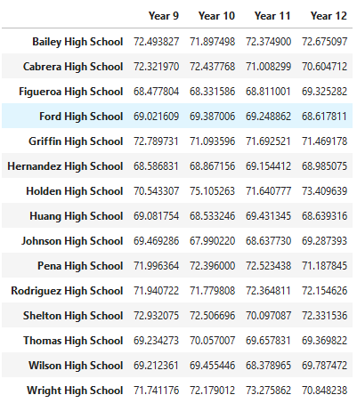 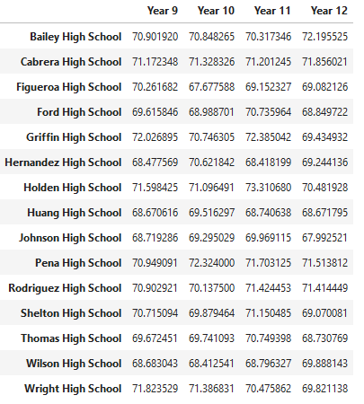

Figure : Year level results for Maths and Reading

Performance based on spending per student provides an interesting insight because as the spending per student increases the performance decreases. It would be interesting to compare this other LGAs, subject to what the spending is used on, it would be expected that the performance increases

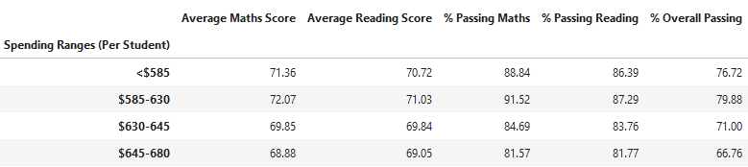

Figure : Spending per student summary

Performance based on school size shows that smaller school sizes perform better than larger schools

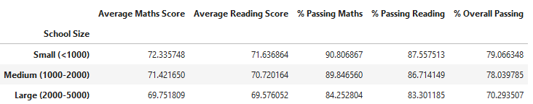

Figure : School size summary

Performance based on school type shows that Independent schools out perform government schools.

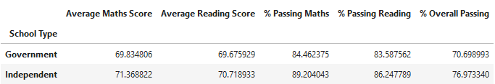

Figure : School size summary

**Detailed analysis of data**

It is important to note that the calculations for several tables was carried out by calculating average of averages, which statistically, is an inaccurate method to use. The calculations should have utilised the average calculation of the raw data.

As indicated in the above summary the analysis showed that increased school budget per student had a negative impact on the Maths and Reading performance. This appears to be contradictory to what is expected, because with higher budget, the school is meant to be able to provide better education.

In addition the independent schools outperformed government schools. Based on the performance and per student budget it can be deduced that government schools had a higher per student budget tan independent school, which in reality is not expecting to be the case.

Bringing the school size into the mix as well, while it can be expected to have smaller schools perform better, it will be more likely to be due to lower student to teacher ratio, which in fact would cost more requiring higher budget. This again appears to be contradictory to what is expected.

Assuming that the data is accurate, the government should investigate how a school with lower per student budget can perform better, because they are overfunding the government schools wasting tax payers money without the benefits.

Reviewing the per school analysis and comparing the school type and performance it is observed that there is a wide range in performance for both government and independent schools. Overall performance is between 81 and 67, and 80 and 67 respectively.

The performance variation based on year level is a good indicator for the school to evaluate teacher performance, however it is best utilized across calendar years as well. There are many factors, not available in this analysis that should be considered when studying that data.

Assuming all things being equal we would expect a very similar result every single year. For Holden High, the data shows some changes in year 12 for Maths (increase) and Reading (decrease) performance when compared to Year 11.

Changes such as this could be impacted by a new teacher, students leaving or coming to the school. For example, in the latter years, students may move to a better performing school to get better overall grades. This in turn would lower the result of the year level they would have been in, as the smarter students move on. However, with student changes, one would expect similar changes (increase or decrease) in both Maths and Reading performance. With opposite direction changes it is more likely that teachers have been replaced, and Maths teacher is better, and the Reading is worse.